t-SNE
Teaching Notes
A from-scratch guide to nonlinear visualization, written as a direct companion to the PCA notes: same goal (see high-dimensional data in 2D), a genuinely different, nonlinear way of getting there.

Contents

1. Where PCA Runs Out of Road
The PCA notes showed how to compress a wide dataset down to 2 dimensions by finding the straight-line directions of maximum spread. That works well when the real structure in the data genuinely lies along a small number of straight directions. But PCA is fundamentally linear, it can only rotate and stretch the data, never bend it. When the true structure is more tangled than a few straight lines can capture, PCA's 2D picture can badly blur groups together that are, in reality, perfectly distinguishable.
A concrete example: 1,797 images of handwritten digits (0–9), each stored as an 8×8 grid of pixel brightness values, 64 numbers per image. Compressing 64 dimensions down to 2:
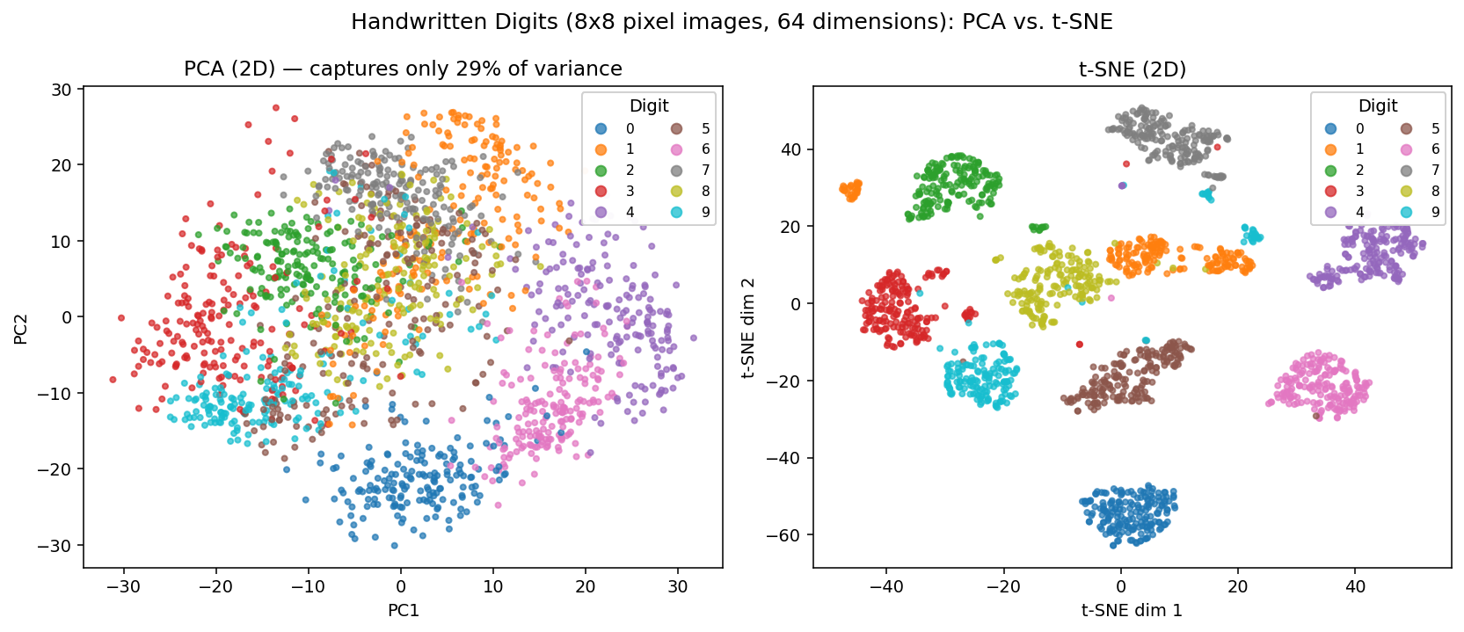
Figure 1. Left: PCA's best 2D view, capturing only 29% of the total variance, digits 3/5/8/9 blur into one smeared region with no clean boundaries. Right: t-SNE's 2D view of the exact same data, all 10 digits form distinct, mostly well-separated islands.
PCA isn't doing anything wrong here, 64-pixel handwritten digits simply don't vary along a small number of straight-line directions; two 3s and a 5 can be closer in raw pixel space than two 3s are to each other, depending on handwriting style, slant, and stroke width. t-SNE, a nonlinear technique, is built specifically to still find the right neighbors even when the data twists in ways no straight line can follow.

2. The Core Idea: Preserve Neighbors, Not Straight-Line Directions
t-SNE (t-distributed Stochastic Neighbor Embedding) asks a completely different question from PCA. Instead of “what direction has the most spread?”, it asks: “for each point, which other points are its close neighbors, and can I place every point on a 2D page so that those same neighbor relationships are preserved?”
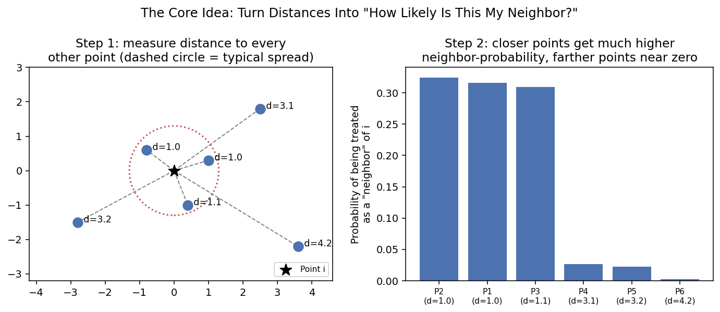
Figure 2. Step 1: measure how far every other point is from point i. Step 2: convert those distances into a probability that each point “counts” as a neighbor of i, close points get high probability, far points get almost none. This probability distribution, one per point, is what t-SNE tries to reproduce in the 2D layout.
t-SNE builds this same neighbor-probability picture separately in the original high-dimensional space and in the 2D layout it's constructing, then nudges the 2D points around, pulling true neighbors closer together and pushing non-neighbors apart, until the two pictures match as closely as possible. (The “t-distributed” part of the name refers to a specific mathematical trick used for the 2D-side probabilities that gives points enough room to spread out and avoid over-crowding at the center, a well-known technical detail, not something needed to use the tool well.) The two things worth remembering: t-SNE only cares about getting local neighborhoods right, and it never promises anything about the exact distances or directions between points, unlike PCA, whose axes and distances trace directly back to the original data.

3. Perplexity: t-SNE's One Big Dial
PCA has no equivalent setting to tune, the directions of maximum variance are what they are. t-SNE has one important setting called perplexity, loosely, “how many neighbors should each point pay attention to?” Changing it can noticeably change the resulting picture, on the very same data:
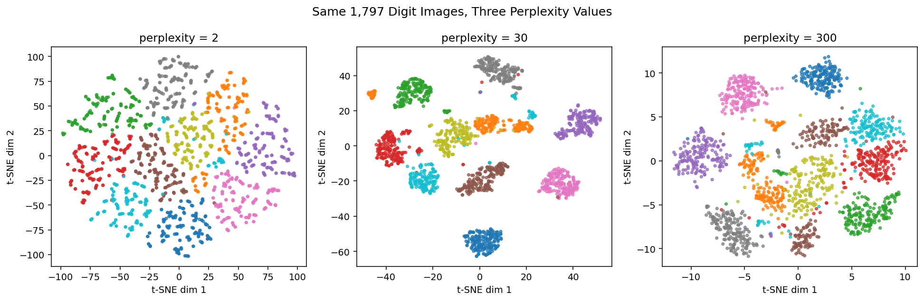
Figure 3. The same 1,797 digit images at three perplexity values. Too low (2): each digit fragments into many small, stringy sub-clusters, the algorithm is only looking at a couple of nearest neighbors at a time. Balanced (30): ten clean, compact, well-separated islands, one per digit. Too high (300, roughly a sixth of the whole dataset): clusters compress and start crowding closer together, edges blur.
- Typical useful range: roughly 5–50, with 30 a common, reasonable starting default.
- Too low: over-fragments genuine clusters into noisy sub-pieces.
- Too high: merges and blurs genuinely separate clusters together.
Unlike PCA's explained-variance percentage, there's no single number t-SNE hands you to confirm you've picked well. The practical fix is exactly what Figure 3 does: run a couple of perplexity values and look for a picture that stays stable and well-separated rather than trusting a single, unexamined default.

4. The Catch: Distances and Cluster Sizes Are Not to Scale
It's tempting to read a t-SNE plot the way you'd read a PCA plot, treating the gap between two clusters, or how large a cluster looks, as meaningful measurements. For PCA that instinct is correct, PCA's axes are just a rotation of the real data, so distances on the plot are real distances. For t-SNE, it is not correct, and the bank customer-segmentation case study makes this concrete: the same 5 K-Means segments, with cluster-center distances measured on both the PCA plot and the t-SNE plot:
Segment pair | PCA center distance | t-SNE center distance | Ratio (t-SNE ÷ PCA)
0 – 1 | 4.80 | 55.52 | 11.6×
0 – 2 | 6.46 | 99.91 | 15.5×
0 – 3 | 5.20 | 73.71 | 14.2×
0 – 4 | 5.76 | 55.26 | 9.6×
1 – 2 | 1.68 | 48.32 | 28.8×
1 – 3 | 1.82 | 48.72 | 26.8×
2 – 3 | 2.21 | 84.87 | 38.4×
2 – 4 | 4.99 | 71.63 | 14.4×
3 – 4 | 5.97 | 99.79 | 16.7×

If t-SNE were simply a zoomed-in, rescaled version of the PCA picture, that last column would be roughly the same number in every row. Instead it swings from 9.6× up to 38.4×, proof that t-SNE is genuinely distorting the geometry, stretching some gaps far more than others, not just magnifying everything uniformly. Segment pair 2–3, for instance, looks relatively close on the PCA plot (2.21) and gets stretched dramatically further apart in the t-SNE view (38.4× the PCA distance) compared to how pair 0–4 is treated (only 9.6×).
Never read cluster size or the gap between two clusters off a t-SNE plot as if it were to scale. The one thing a t-SNE plot is built to get right is which points are close neighbors of which, nothing about absolute or even relative distance is preserved.

5. PCA vs. t-SNE, Side by Side
 | PCA | t-SNE
What it optimizes | Directions of maximum variance (linear) | Matching local neighbor relationships (nonlinear)
Speed on 20,000+ rows | Fast, scales easily | Slow; typically run on a subsample
Axes have real meaning | Yes (loadings trace to original features) | No (axes can rotate/flip between runs)
Distances on the plot are real | Yes | No (Section 4)
Deterministic | Yes, same input always gives same output | Only with a fixed random_state; sensitive to perplexity
Good for | General-purpose reduction, preprocessing, interpretable axes | Visual exploration when PCA's linear view looks tangled/overlapping

6. Strengths, Weaknesses, and When to Use t-SNE

Strengths
- Captures nonlinear structure that a straight-line technique like PCA cannot, often revealing cleanly separated groups where PCA shows one smeared blob (Figure 1).
- Excellent specifically for visual exploration: “are these groups actually different, or does it just look that way from a bad linear angle?”
- Works well alongside clustering results as a sanity check, as in the bank case study, where it confirmed the same 5 segments K-Means and PCA had already found.

Weaknesses
- Computationally expensive, doesn't scale comfortably to tens of thousands of rows without subsampling.
- Distances and cluster sizes on the plot are not meaningful (Section 4), a common and serious misreading.
- Results depend on the perplexity setting (Section 3), and there's no single built-in score (like PCA's explained variance) confirming a good choice.
- Axes carry no fixed interpretation, and can even flip or rotate between runs with different random seeds, unlike PCA's loadings.
- Not a general-purpose preprocessing step, it's built for 2D/3D visualization, not for feeding compressed features into a downstream model the way PCA components often are.

Rule of thumb: start with PCA. Reach for t-SNE specifically when a PCA plot looks ambiguous, overlapping, or smeared, and the real question is whether distinct groups actually exist. Treat t-SNE strictly as a picture to look at, never as a source of features, distances, or measurements for anything downstream.

7. Summary Cheat Sheet
- PCA finds straight-line directions of maximum variance; t-SNE instead tries to preserve which points are close neighbors, even along bent or tangled structure PCA can't follow.
- t-SNE works by converting distances into neighbor probabilities, in both the original high-dimensional space and the 2D layout, then arranging the 2D points so those two probability pictures match as closely as possible.
- Perplexity is t-SNE's main setting (roughly “how many neighbors to consider”); too low fragments clusters, too high merges them. Always check a couple of values, there's no single metric to optimize.
- t-SNE distances and cluster sizes are not to scale, confirmed directly by comparing PCA vs. t-SNE inter-cluster distances on the same data (Section 4). Only relative neighborhoods are meaningful.
- t-SNE is slower and doesn't scale as well as PCA, subsampling large datasets before running it is standard practice.
- Use PCA by default; reach for t-SNE when a PCA plot looks ambiguous and you specifically need to check whether groups that look blended are, in fact, genuinely separate.

